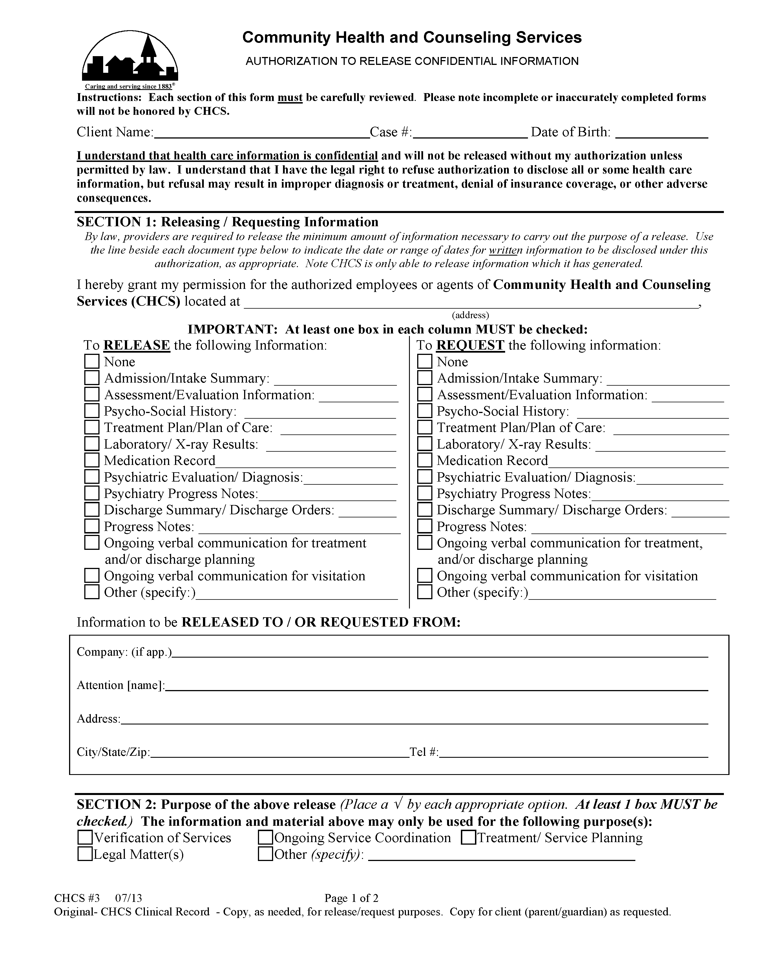
Batman
01/01/1979

2901 Hubbard Street Ann Arbor, MI 48109-0000
MI
Axiom Requisition Copy Service
Records
2869 Jolly Road
(877) 886-5090
Okemos,
MI
48864
Fax: (517) 886-4116

FROM 01/01/1979 TO PRESENT: Any and all MEDICAL RECORDS, including but not limited to patient history form(s), reports, etc. pertaining to Batman SSN: xxx-xx-5555, DOB: 01/01/1979.
x
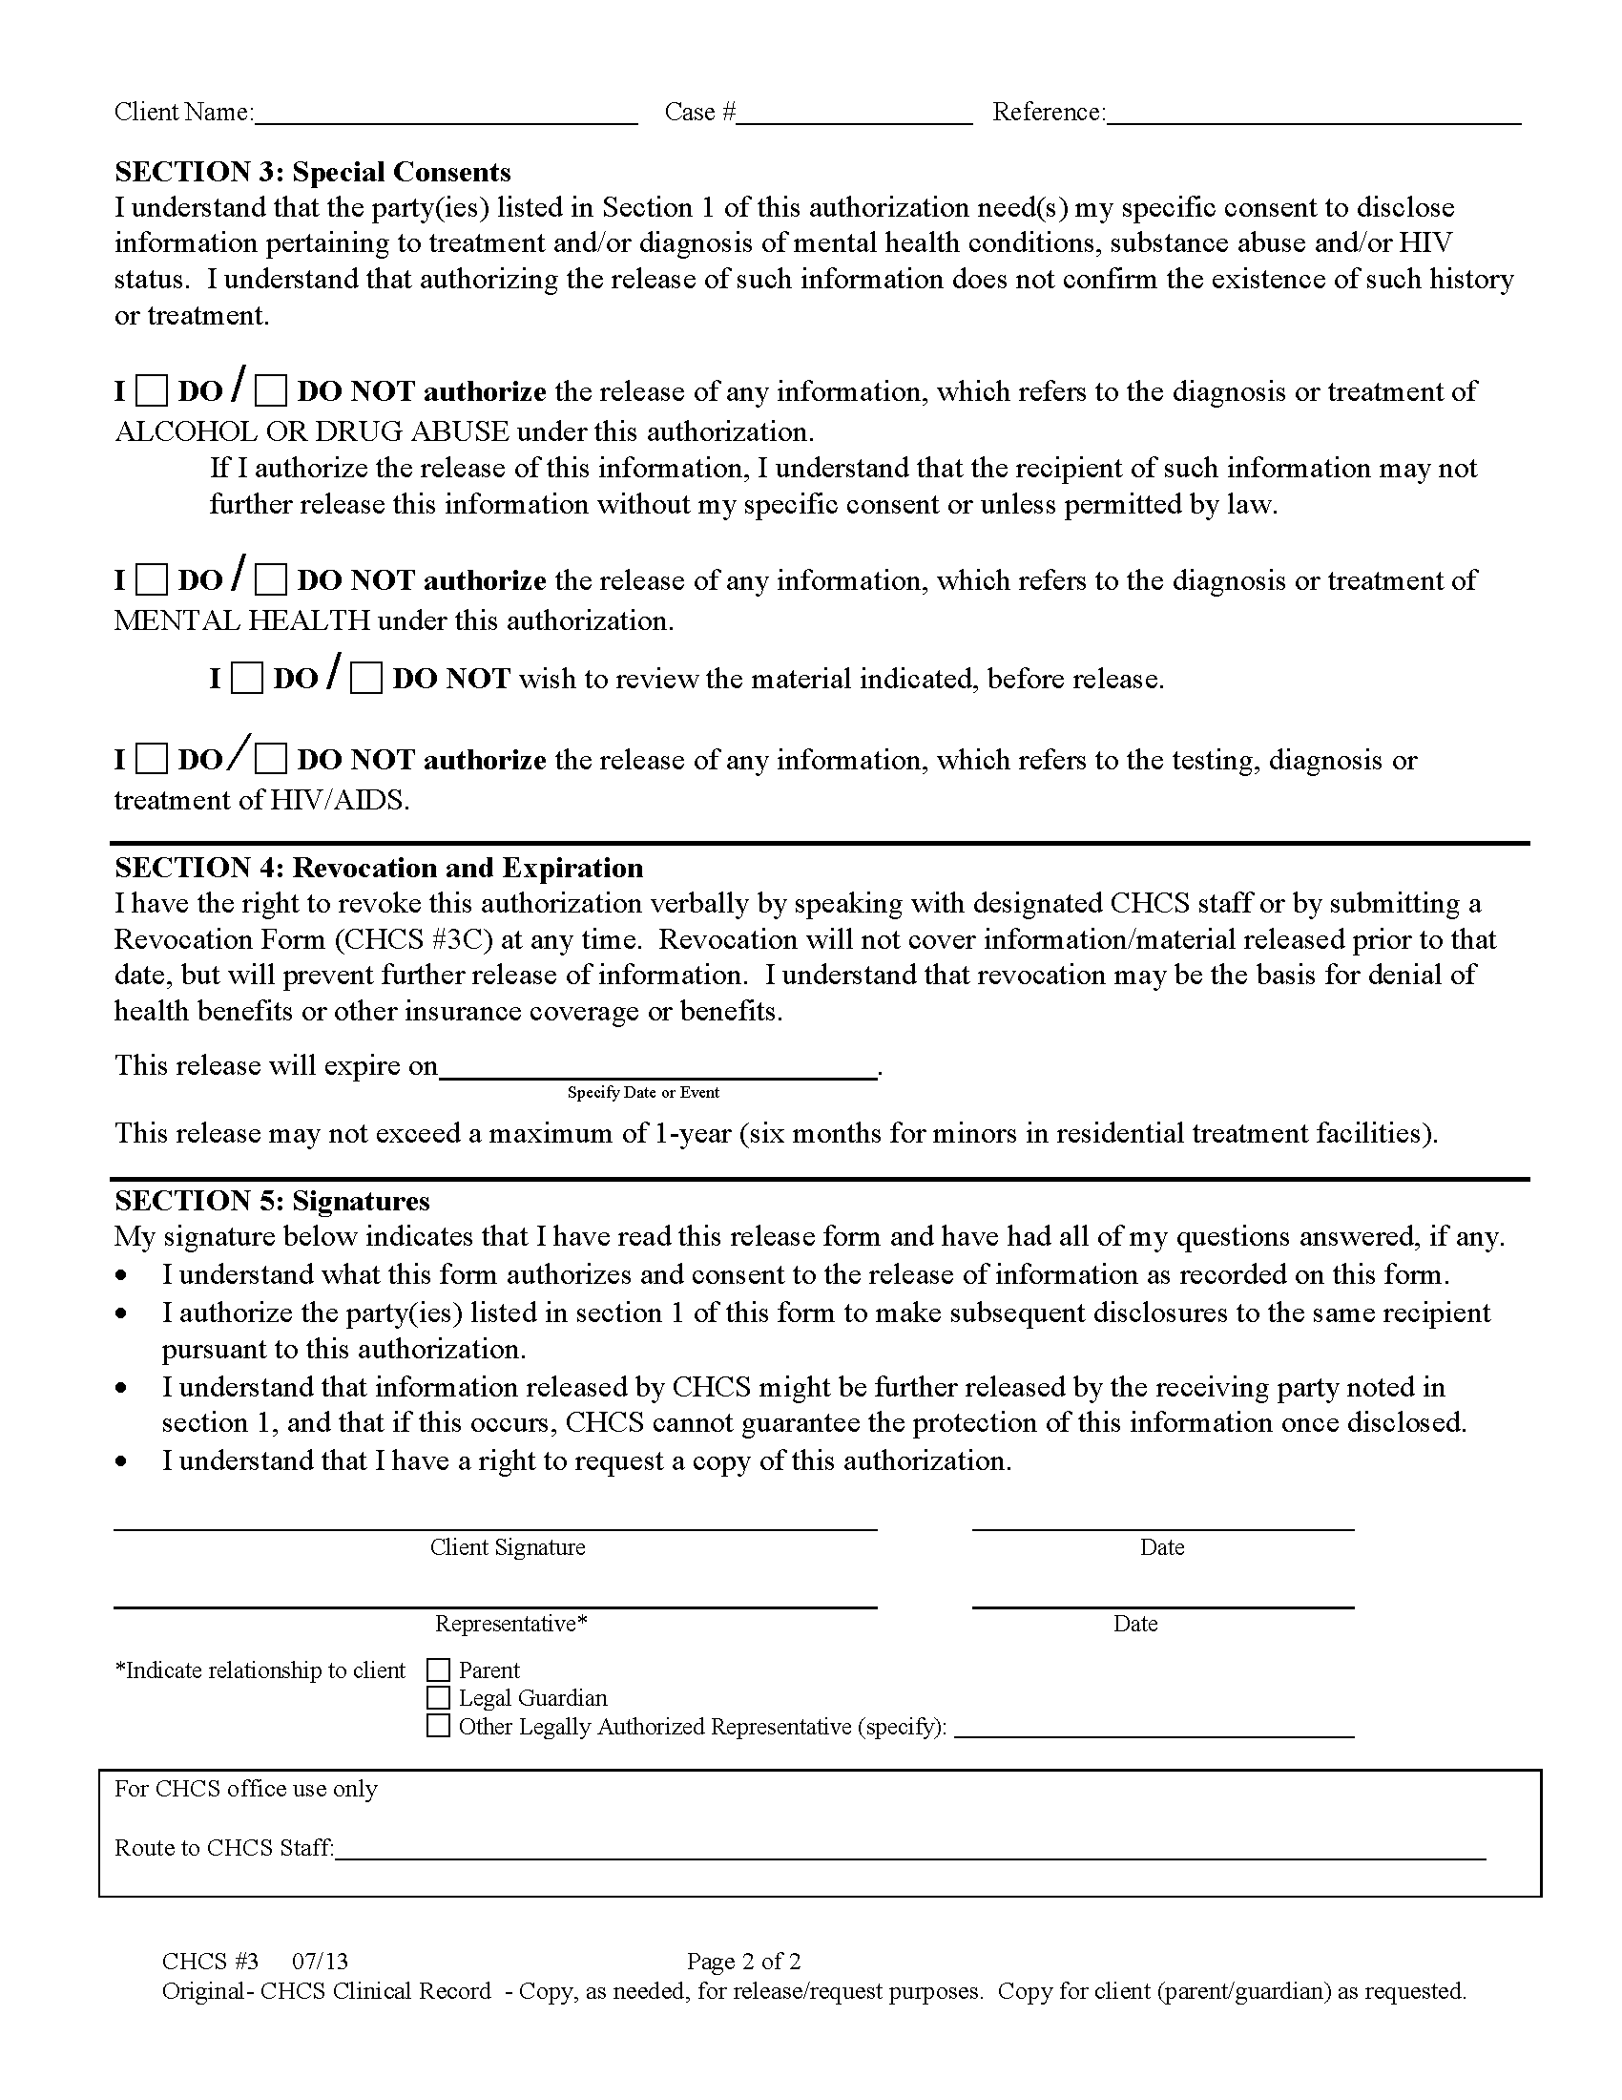
Batman
x
x
x
End of Legal Matter

